**EXPERIMENT 7**

**Create a Virtual Machine with 1 CPU, 2GB RAM, and 15GB storage disk using a Type 2 Virtualization Software**

Step 1: Create a new virtual Machine

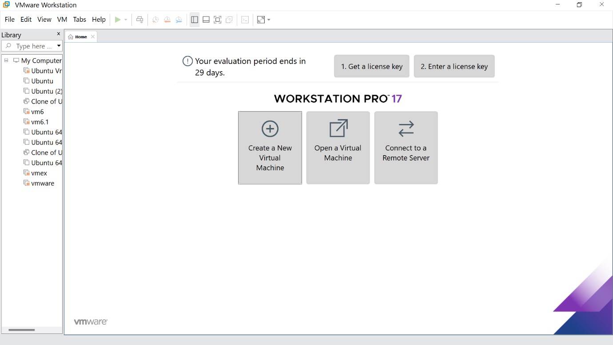

Step 2: Click the Typical option and click Next

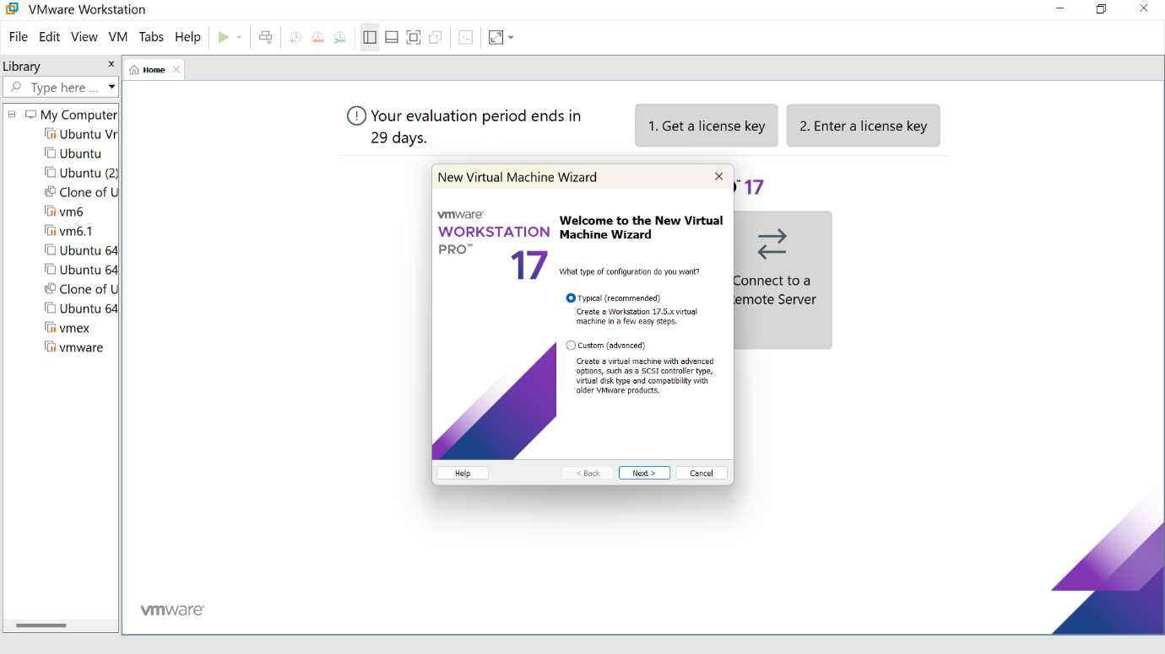

Step 3:Click the install option and proceed to the next step

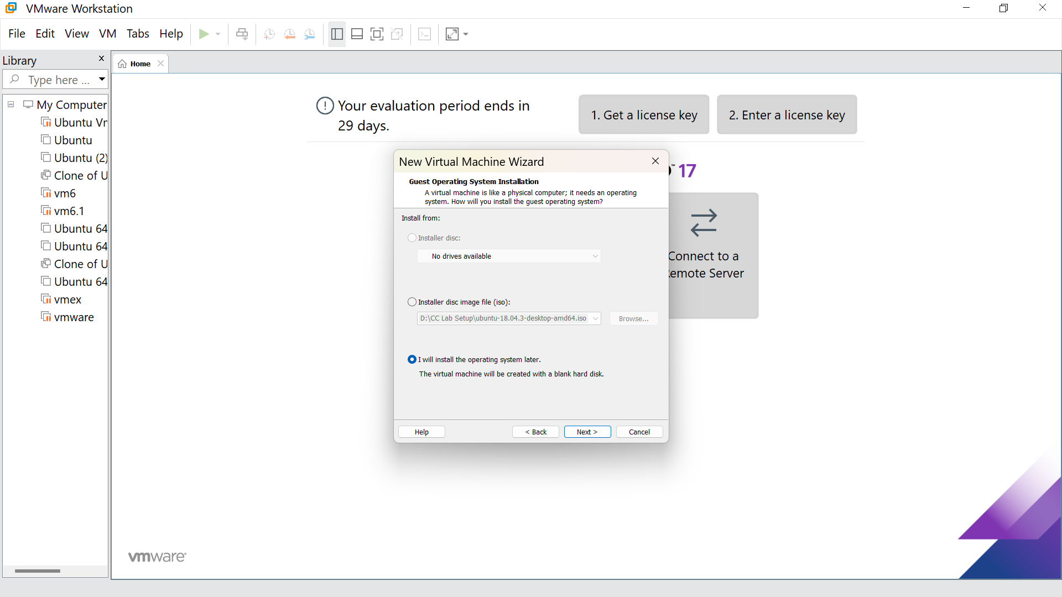

Step 4 : Select the Linux option and click Next

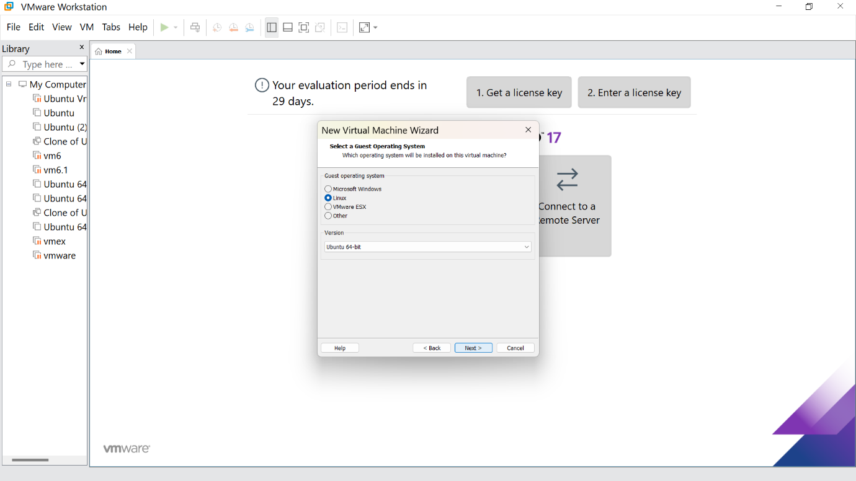

Step 5: Give the name for the virtual machine(optional) and click next

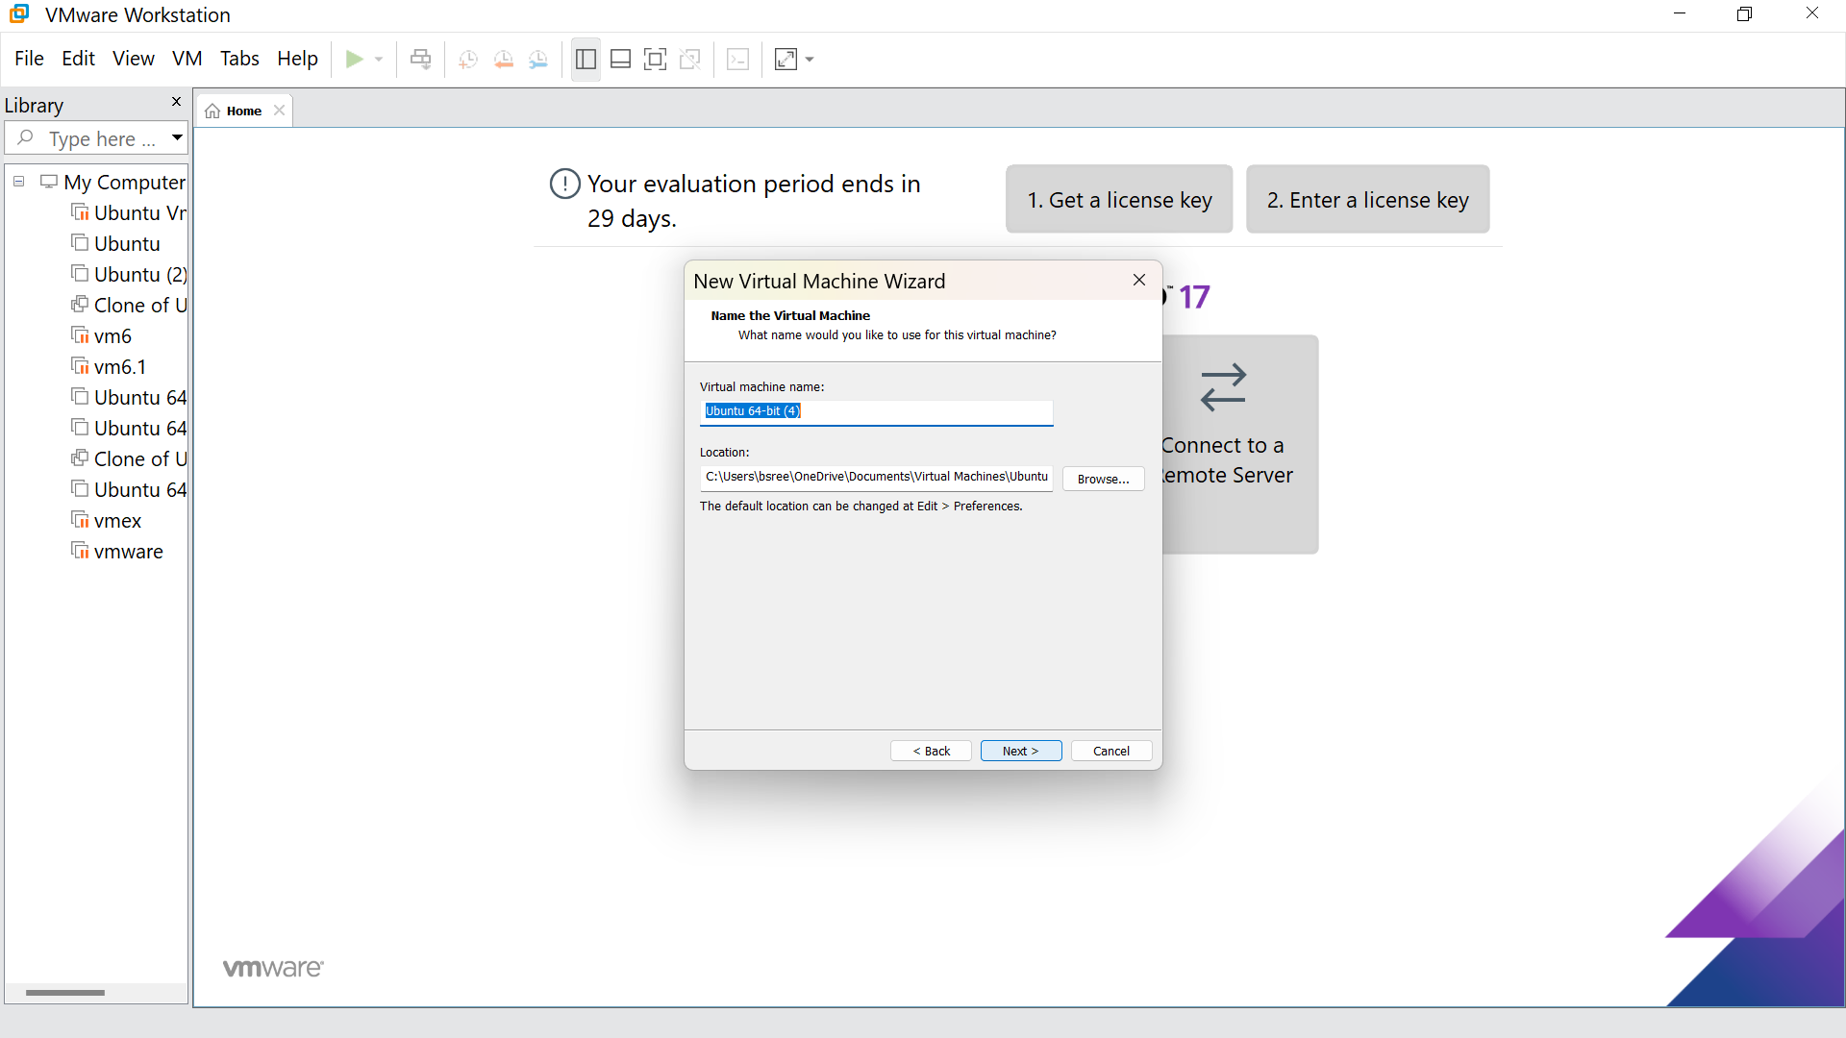

Step 6: Give the maximum disk size as 15.0 GB and click next

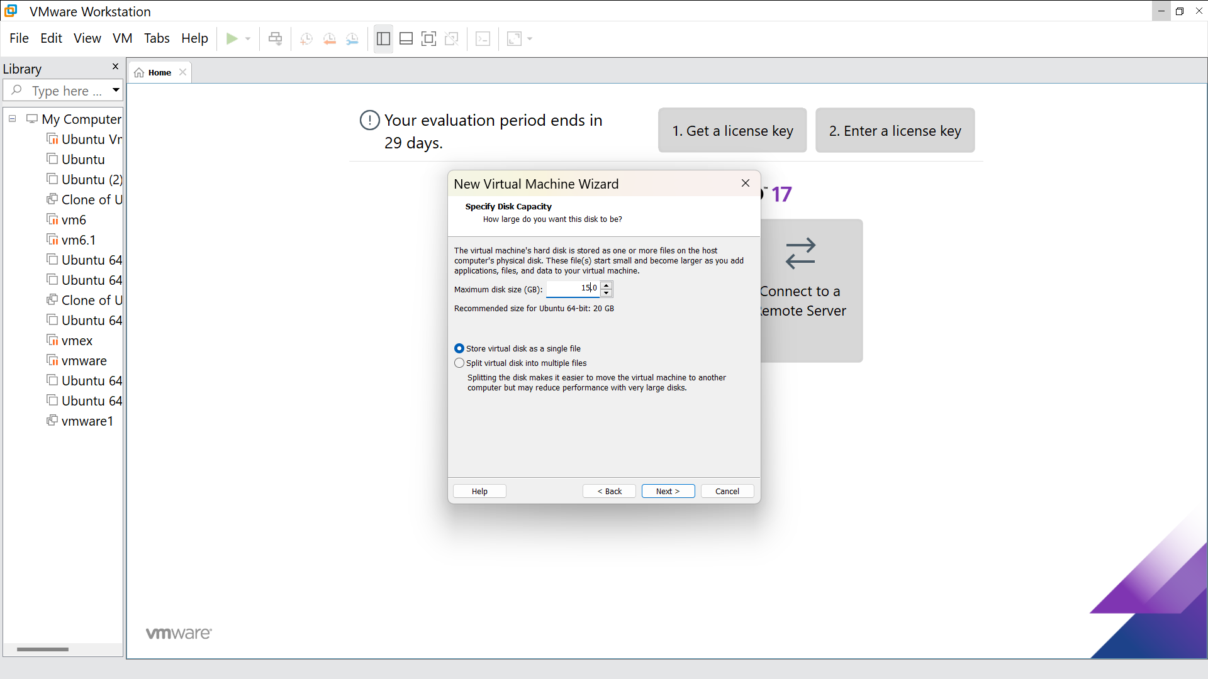

Step7:Our new VM is ready, click finish

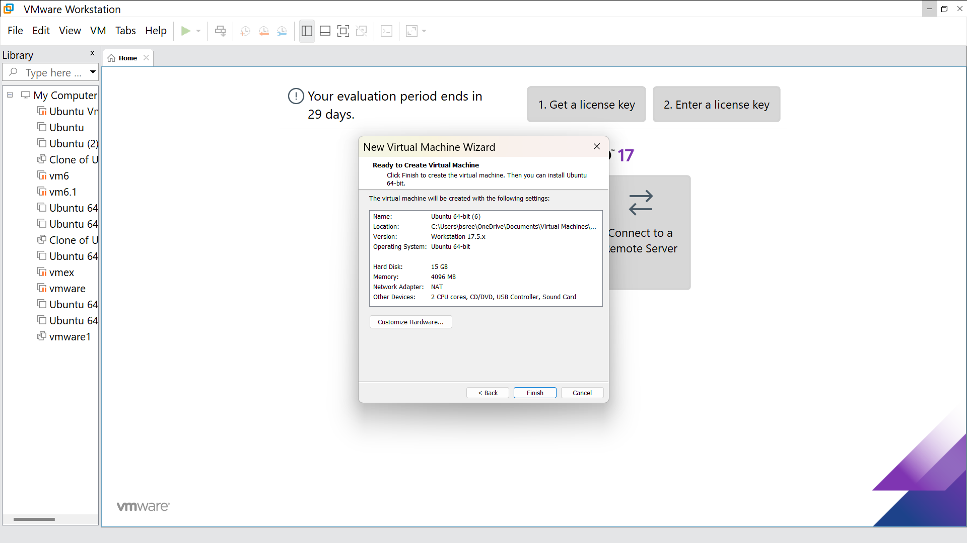

Step 8: Go to memory and change that to 2 GB

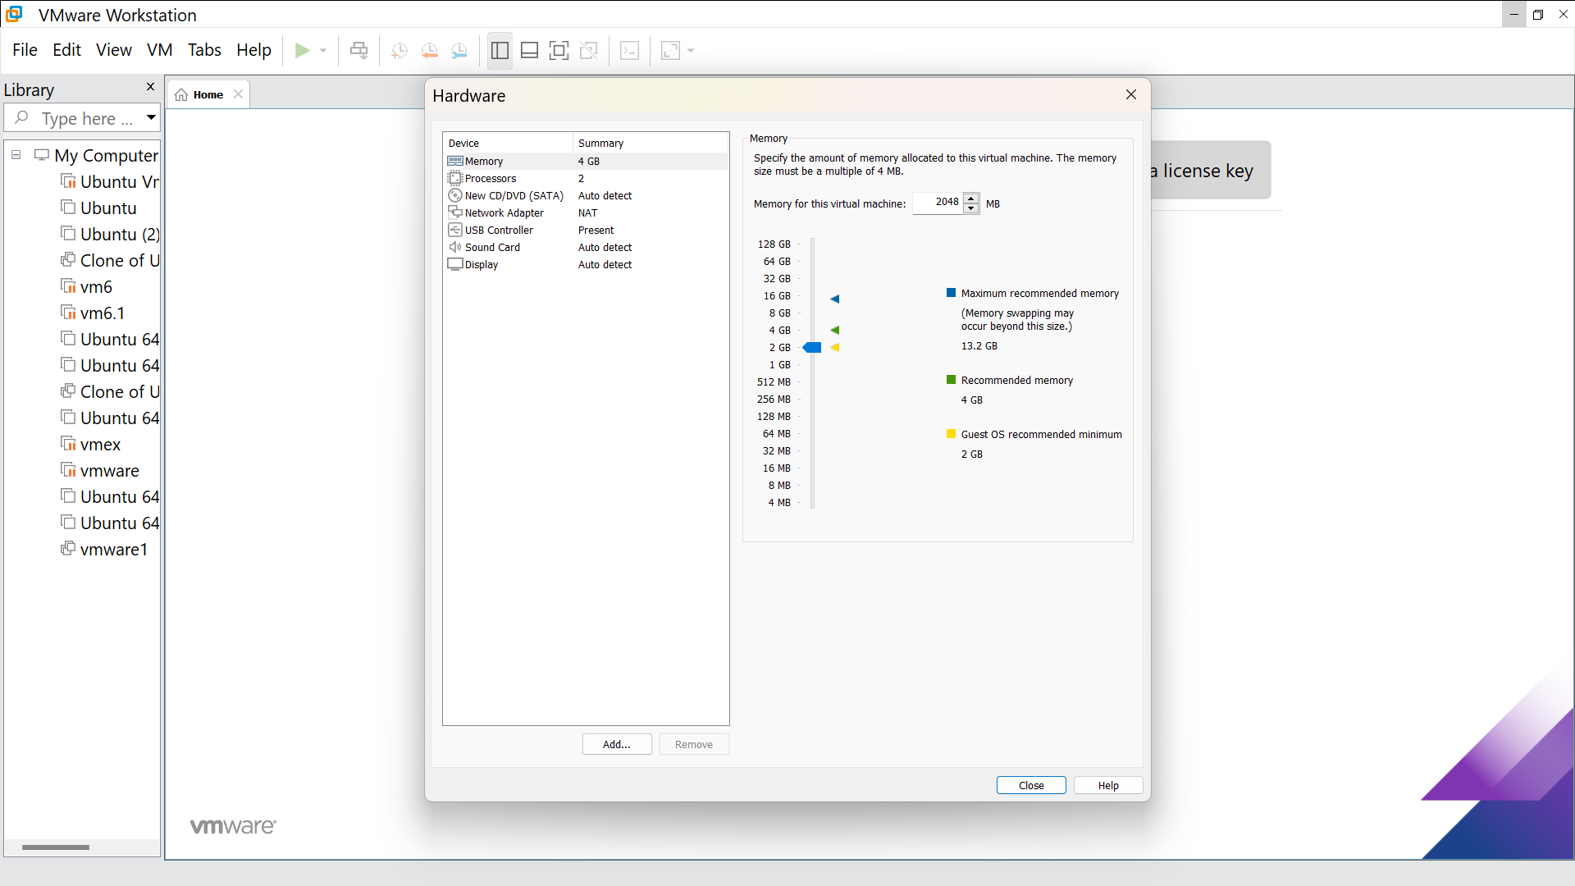

Step 9: This is the creation of a VM

